E-Learning Newsletter
Online Safety and Education-
Links to helpful websites, training and news

18th December 2020
Hello everyone and Seasons Greetings,
This week’s newsletter contains some links to websites, apps and other technologies which will hopefully bring some extra joy and laughter to your family this Christmas.
But before I list those, I would just like to take the opportunity to say thank you for all your support and engagement with the development of the learning platform and its launch this year.
I only started working at Disability Action Yorkshire in October and yet, in only such a short period of time, I have been able to make links with so many of you, received so much kind and helpful feedback, encouragement and support from you all. Thank you for all your help with making this project what it is becoming.
Currently we are distributing flyers and promoting the platform through our social media channels and by making links with organisations who will hopefully be able to spread the word far and wide. Myself, and the whole team at Disability Action Yorkshire, are very excited about the future and what 2021 will bring.

Hopefully, we will see more people signing up to the courses and classes on the platform in the coming months- and in turn be able to create an online community of disabled learners who support, communicate and encourage one another to strive for every goal and dream they wish for. After all, that is what new years are all about!

Of course, if you believe that what can be done now, shouldn’t have to wait until tomorrow or the new year; to join the platform or know someone who would like to, read the flyer at: https://www.disabilityactionyorkshire.org.uk/services/training/online-e-learning-platform/ OR call on 01423 449314 to speak to the E-Learning Coordinator.

As always, I have included the last Happy News edition of 2020- which focuses on all the good things which have happened this year; so enjoy!

In the meantime, I wish you all a very peaceful, joyous and wonderful Christmas and a very Happy New Year, and I will end with one of my favourite quotes:

“Where there is kindness there is goodness and where there is goodness, there is magic”. ~Cinderella.

Kind regards,

Harriet Walker,
E-Learning Coordinator

Activities, fun and other festive technology

- A personal message from Santa- Visit: https://www.portablenorthpole.com/
Receive a personalised video message or phone call from Santa at the North Pole. Just register with an email for a free video message. Other premium add ons cost money.

- Have a giggle with some Winter Madlibs. Print off the story and complete the blanks by using family member names, adjectives and nouns to create a silly unique story. Visit : https://www.woojr.com/winter-mad-libs/ for the different Winter Templates.

- Track Santa on Christmas eve by using the Norad Santa Tracker: https://www.noradsanta.org/ Follow Santa on his journey around the world by following him via satellite navigation!

- Antarctica Street view. Use Google Earth to visit the North Pole or Antarctica or anywhere around the world. https://www.google.com/maps?ie=UTF8&t=h&q=Antarctica&layer=c&cbll=-62.59614,-59.906359&panoid=XPAF13EigYrQhZe6NsQ7TA&cbp=12,277.55,,0,-0.96&hq&hnear=Antarctica&ll=-62.59614,-59.906359&spn=0.000732,0.002516&z=14&source=embed&utm_campaign=en&utm_medium=et&utm_source=en-et-na-us-gns-svn or search for ‘Antarctica’ in the Google Earth app.

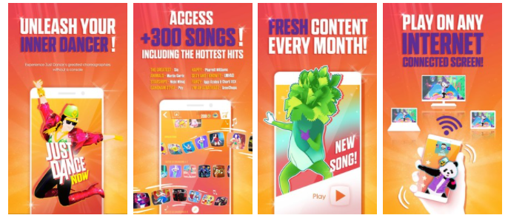
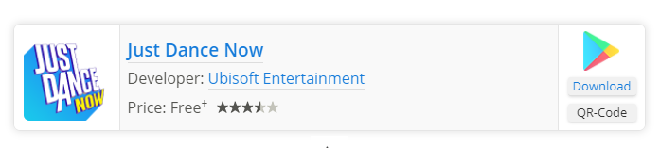
- Just Dance game via your SMART TV or via Chromecast/ Amazon fire stick. Simply download the Just Dance App to your smartphone, and use your phone as the controller!

- Alien Invaders Chromecast game. Use your Smartphone as the handset and defeat the aliens on the TV! Download the classic arcade game from the Google Play store.

- 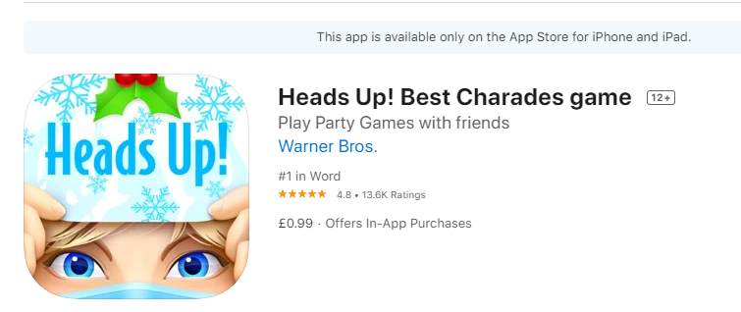The virtual version of the Sticky Note on the forehead!

Visit: https://ting.com/blog/smartphone-games-on-the-tv-everyone-can-play/ for more family games, ideas and activities.

